Error: No measure defined in a reporting enabled view

Note the Calculation view must have at least one measure field.

Note: This view VK_CALCVIEW cannot be seen in SE11

1) Go to Modeler perspective

2) HANA system-Content-package name(pkgTRAINEE10). Right click. New -> Calculation view

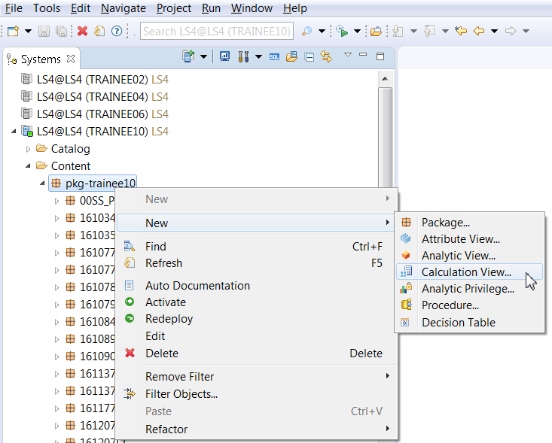

3) Given name to the view name VKCALC_VIEW. Choose Type as SQL Script. Finish.

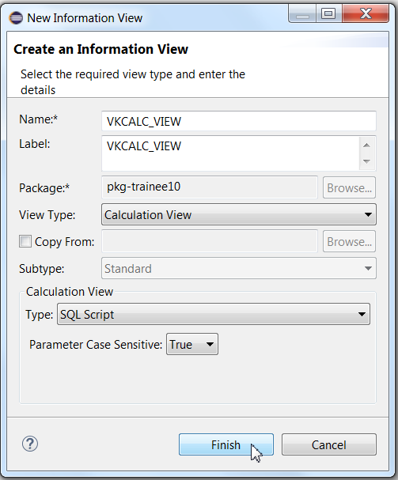

4) Click on the Script view and add the below code

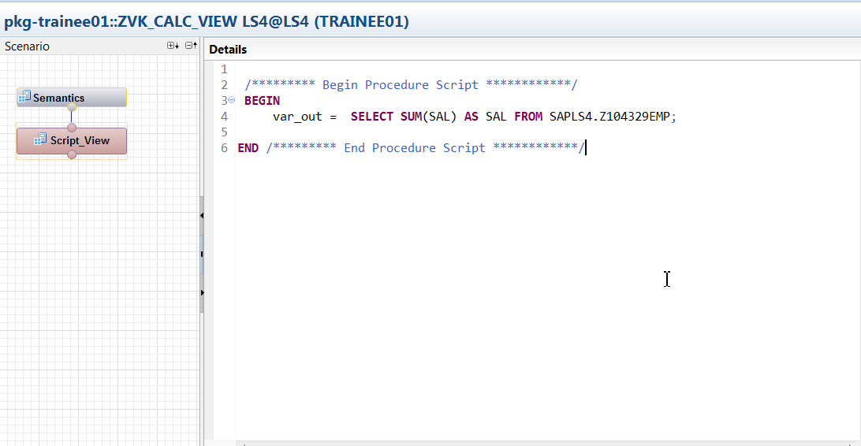

/********* Begin Procedure Script ************/

**BEGIN**

var_out = **SELECT** **SUM**(SAL) **AS** SAL **FROM** SAPHANADB.Z104329EMP;

**END** /********* End Procedure Script ************/

5) To Add the field names, go to Right corner Output tab. Drop down- Add Columns from.

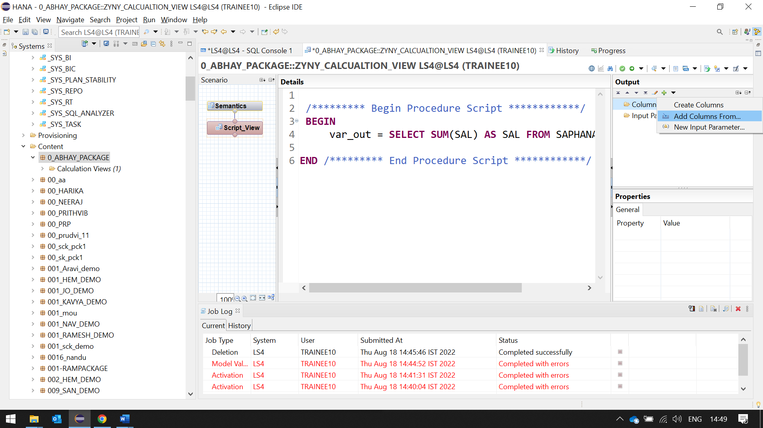

6) Give name of table created in SE11. Z104329emp. 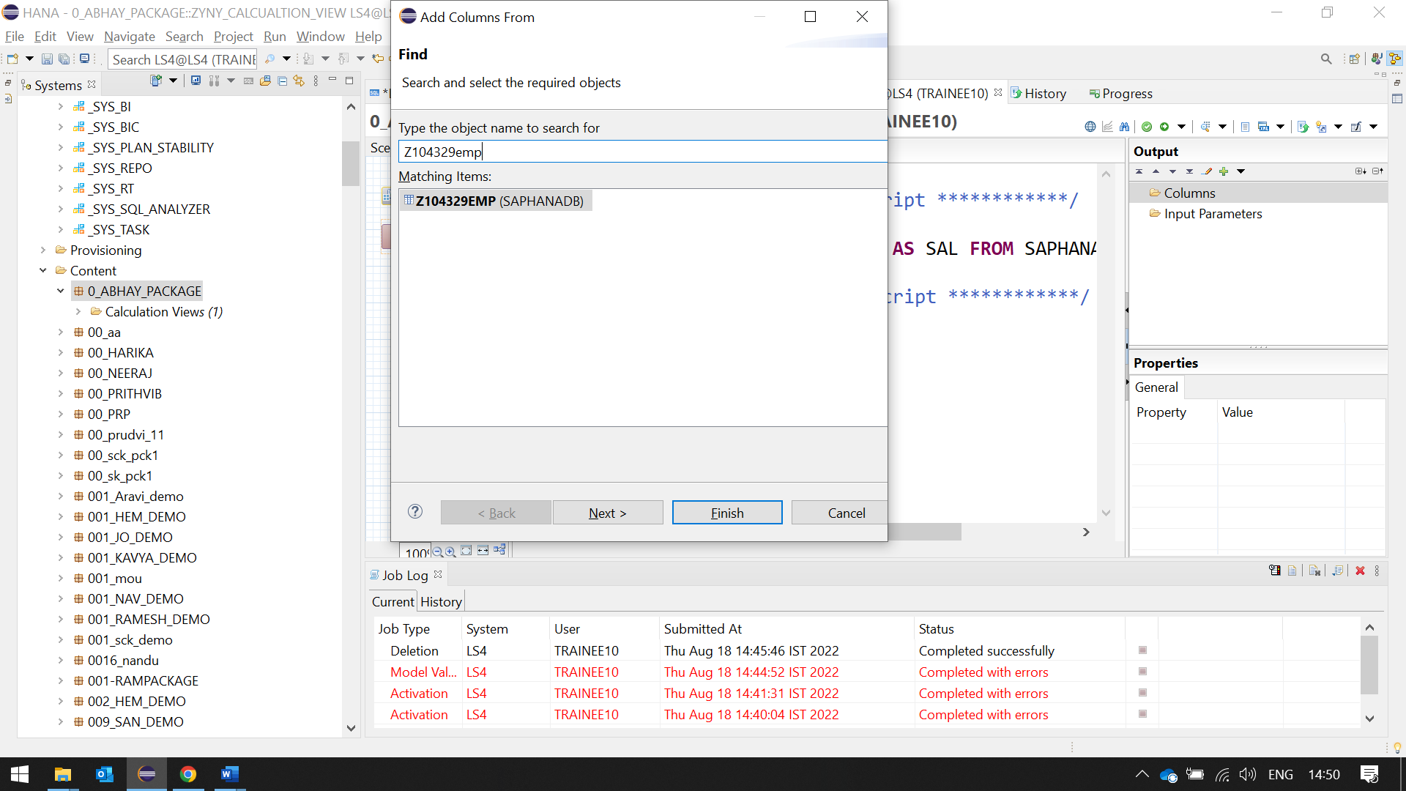

7)Add sal. Finish.

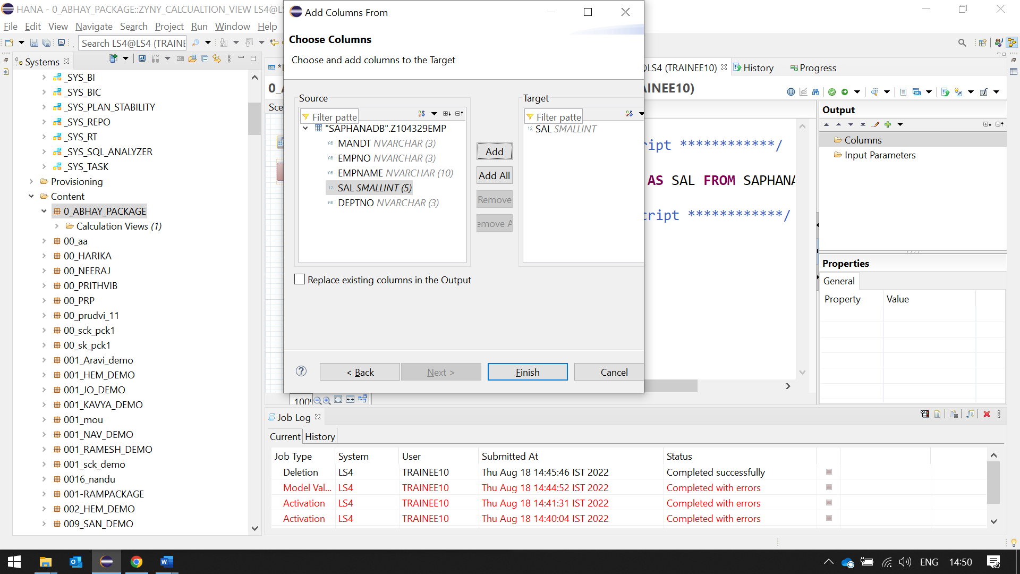

9) Save and validate. Save and Activate.

10) See Data Preview.

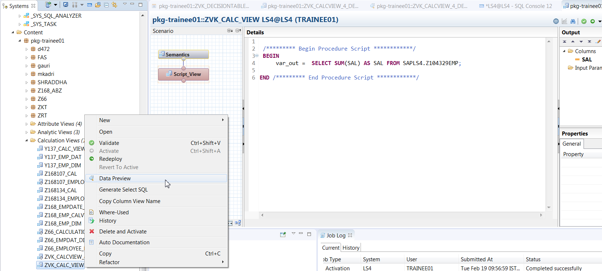

11) Right click on view name- Generate Select SQL. Execute it.

12) Change the sum to avg and execute it.

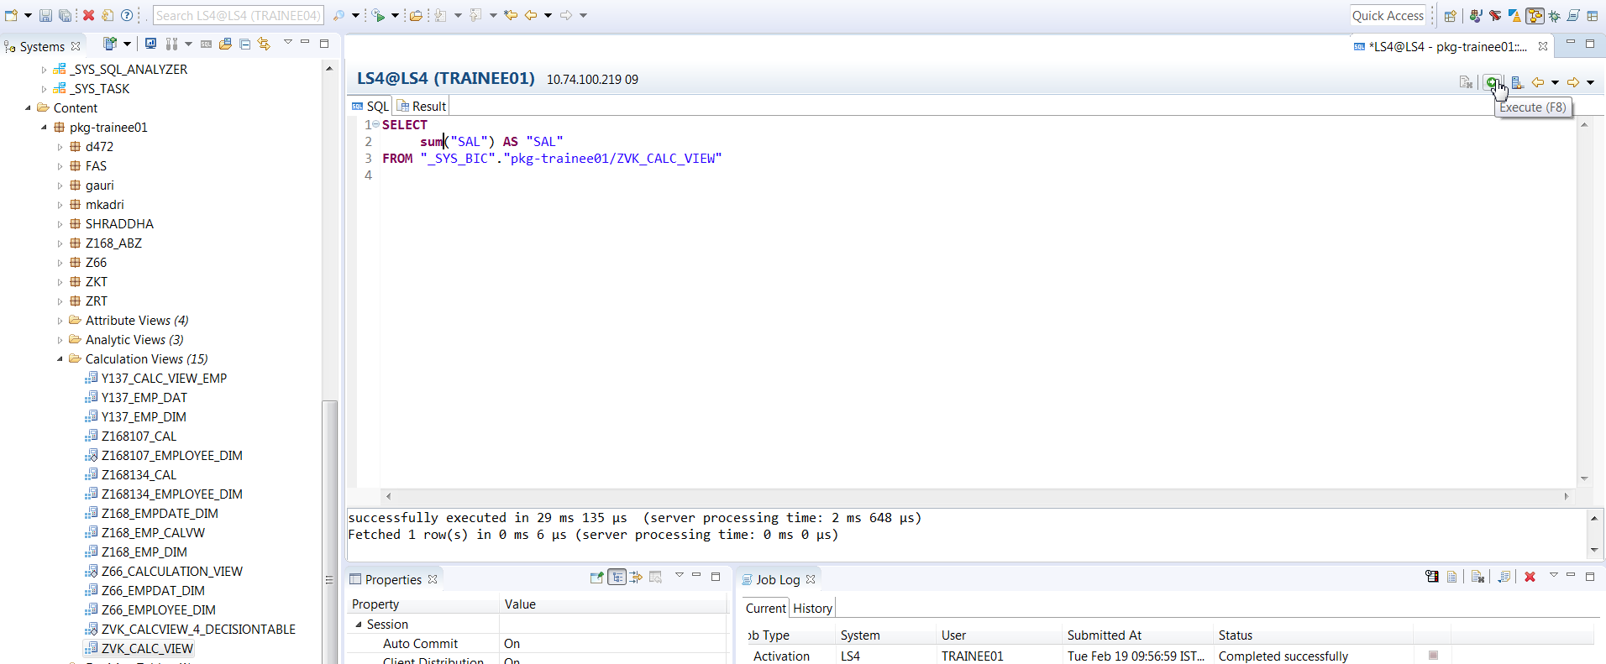

19) You can also check the view in the _SYS_BIC schema. Right click and See Data preview.

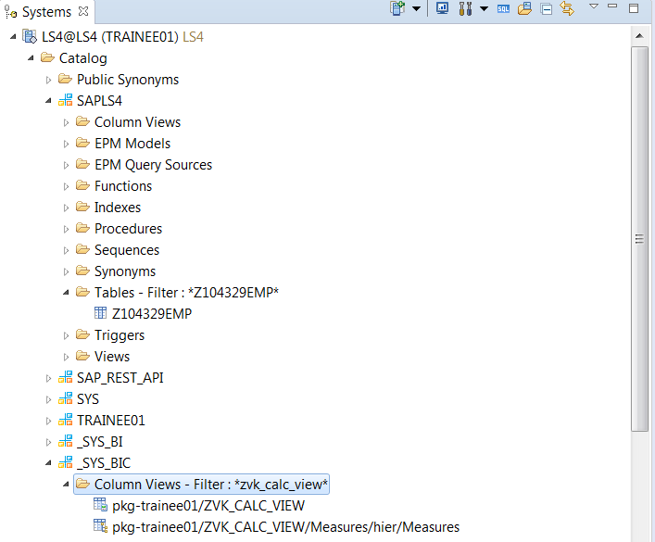

A calculation view can also be created on Multiple fields.

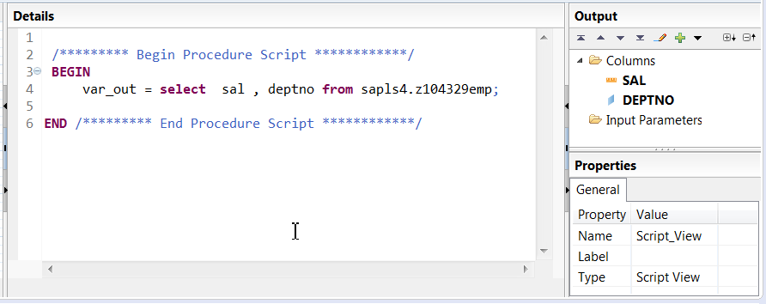

Note: Open in SQL Editor and Generate Select SQL will display the same SQL.